Code Review: I2307007
Reviewer: James Wood
Date: July 12th, 2023

Bugs
- I do not see either column locking. I checked in TFS and it appeared that all of the code was UI designer code, so I opened the VB6 project to see what was changed. I did not see either column being locked:
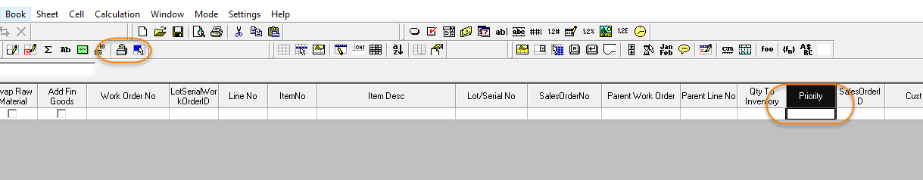
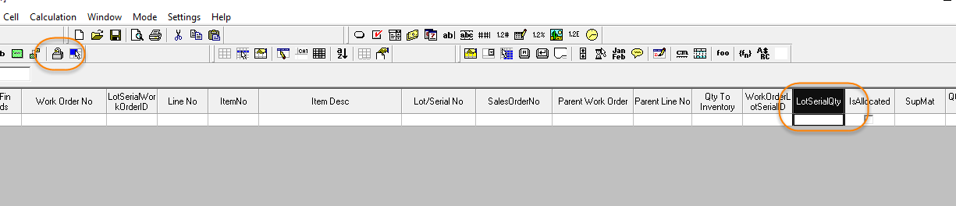
Just to give it a quick test myself, I tried locking them through this designer and found that the Text field LotSerialQty locked correctly; it did not accept any keyboard input. However, when testing the Priority column, while it did not allow me to select a value through the combo, when typing into the column it blew up, so simply locking the column will not be enough.
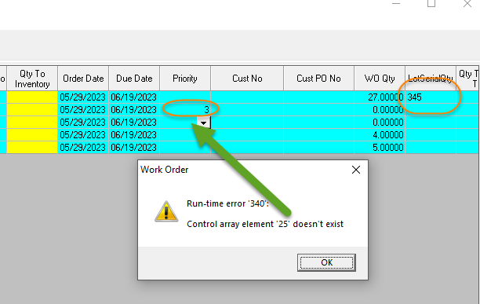
Ignore the highlighted values in the cells as this DLL is built off of the current changes, not with my locking changes. However, that error is the same as what I received even when I locked the Priority column. Further handling in the code appears to be necessary.

Preventative Action/Safety

Design/Architecture (Duplication, appropriate project, namespaces, maintainability)

Data Model (Naming, good design, needs index?)

Performance (Minimize DB hits, excessive loops, queries, scalable)

UI (Alignment, naming, standardization, tab order)

Error Handling (Behind events, appropriate parameter checking)

Cleanup (Dispose code, remove handlers, large data objects)

Readability (Well-named variables, methods, clear algorithm, is it understandable)

Comments (Useful, explains why rather than how)

Message Boxes (Grammar, spelling, captions, appropriate icons)

Ticket Management (Release Branch?, Testing Notes)

Extras

